Company overview
Iveris Finance and Governance Advisors (IFIGA) Ltd. is a Rwandan-registered private limited company that provides high-quality consultancy and advisory services in sustainable finance, Environmental, Social and Governance (ESG) reporting, and social and environmental performance management. IFIGA Ltd. is dedicated to supporting microfinance institutions (MFIs), cooperatives, small and medium-sized enterprises (SMEs), and development partners to strengthen their institutional capacity, align with international sustainability standards, and deliver measurable positive impact for people and the planet.

Vision, Mission & Core values

Vision
To be the leading trusted partner in building resilient, responsible, and sustainable financial and impact institutions in Rwanda and beyond.

Mission
To empower MFIs, cooperatives, SMEs, and development actors to achieve sustainable growth by strengthening financial performance, embedding robust social and environmental standards, and aligning with international best practices that create lasting value for clients, communities, and the planet.

Core values
- Integrity: We uphold the highest standards of professional ethics, transparency, and accountability in all our engagements.
- Impact: We are committed to delivering tangible, measurable positive outcomes for our clients and their stakeholders.
- Innovation: We embrace forward-thinking solutions and continuously adapt to emerging sustainability and finance trends.
- Partnership: We build strong and collaborative relationships based on trust, respect, and shared goals.
- Excellence: We deliver high-quality, client-centered services that exceed expectations.

Target clients
IFIGA Ltd. targets a clearly defined and high-potential client base with increasing demand for sustainability, governance, and performance improvement services:
- MFIs, SACCOs, and Cooperatives
Institutions seeking to strengthen governance, improve operational and financial performance, comply with sustainability standards, and position themselves to access climate and impact financing.
- Small and Medium-Sized Enterprises (SMEs)
Businesses aiming to integrate sound environmental, social, and governance practices, enhance credibility, and access sustainable and impact-oriented financing.
- Development partners, donor-funded programs, and NGOs
Organizations requiring expert support in the design, implementation, monitoring, and evaluation of sustainability and impact-focused initiatives.
- Impact investors and funds
Regional and international investors needing reliable local partners to conduct due diligence, assess sustainability performance, and verify social and environmental impact.
This targeted approach ensures efficient resource allocation, stronger market penetration, and higher client conversion.

Services & value proposition

Core services
IFIGA Ltd. offers a comprehensive and integrated portfolio of advisory and consultancy services designed to strengthen financial performance, governance, and sustainability across client institutions. Its core service lines include:
- Strategic/business planning, feasibility studies, and institutional strengthening:
Providing integrated support in the preparation of strategic plans, business plans, and feasibility studies, while strengthening organizational structures, governance, and overall institutional effectiveness. This includes financial planning, budgeting, and performance analysis, alongside practical advisory in strategy formulation and operational planning to support sustainable growth.
- Policies, procedures, and governance support:
Development of practical policies, guidelines, and operational manuals, including governance arrangements, credit/loan management processes, risk management approaches, liquidity management, and internal control practices.
- Independent Social and Environmental Performance Management (SEPM) Audits:
Conducting rigorous and independent assessments of how MFIs, cooperatives, and SMEs manage their social and environmental performance, including client protection, governance practices, and institutional impact. These audits provide credible, objective insights to improve performance and meet investor, donor, and regulatory expectations.
- ESG assessments and reporting:
Supporting clients in measuring, analyzing, and clearly reporting their environmental, social, and governance (ESG) performance, ensuring transparency and alignment with international requirements.
- Sustainable finance advisory:
Advisory support in green finance, climate finance, impact investment, and responsible finance solutions to help clients access and effectively utilize sustainable funding opportunities.
- Training and capacity building:
Delivery of tailored and practical training programs covering ESG standards (e.g., Cerise + SPTF, IFC), governance, financial management, credit operations, risk management, and institutional performance improvement.
- Accounting, tax advisory, and compliance:
Provision of accounting, tax advisory, and compliance services in line with applicable laws and professional standards.
- Research, surveys, and analytical studies:
Conducting research, surveys, and analytical work to support evidence-based decision-making in financial services and sustainability.
- Other advisory services:
Provision of additional professional and consultancy services aligned with client needs and the company’s mandate.

Value proposition
IFIGA Ltd. delivers high-value, practical, and results-oriented advisory services that enable clients to strengthen performance, ensure compliance, and achieve sustainable growth. Its value proposition is built on the following key pillars:
- Integrated and end-to-end solutions:
Clients benefit from a seamless combination of services that bring together financial management, governance, and sustainability. This integrated approach ensures consistency, reduces fragmentation, and delivers more effective and lasting results.
- Strong local expertise with international best practices:
IFIGA Ltd. combines a deep understanding of the Rwandan and regional context with the application of internationally recognized standards, ensuring that solutions are both relevant and globally credible.
- Tailored and practical support:
Services are customized to each client’s specific needs, institutional capacity, and strategic objectives. The focus is on delivering practical, implementable solutions rather than generic recommendations.
- Results and impact-oriented approach:
IFIGA Ltd. focuses on delivering measurable improvements in institutional performance, financial sustainability, and social and environmental outcomes (helping clients achieve tangible results).
- Trusted partnership and long-term value creation:
IFIGA Ltd. positions itself as a long-term partner, supporting clients throughout their growth journey with reliable, high-quality advisory services that build trust, strengthen resilience, and create sustainable value.
Logo (Draft)
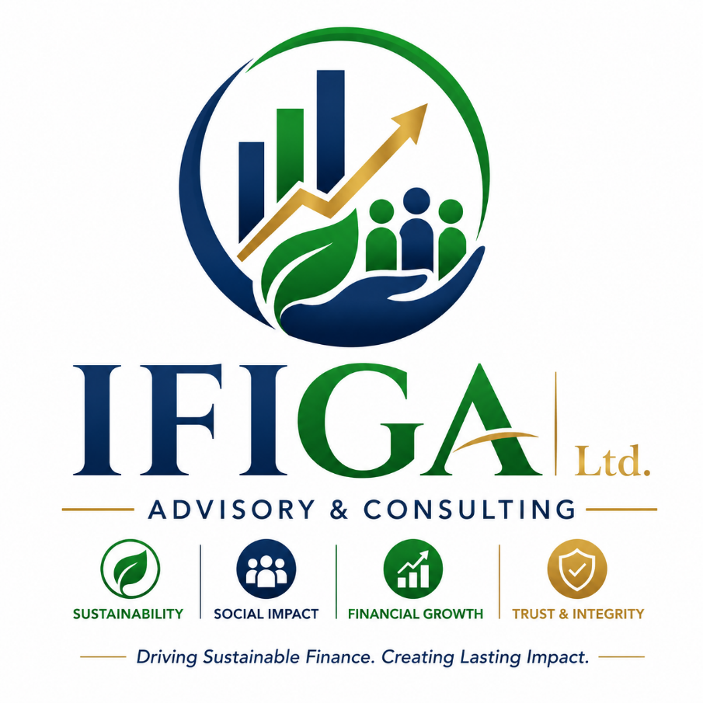
Stamp (Draft)

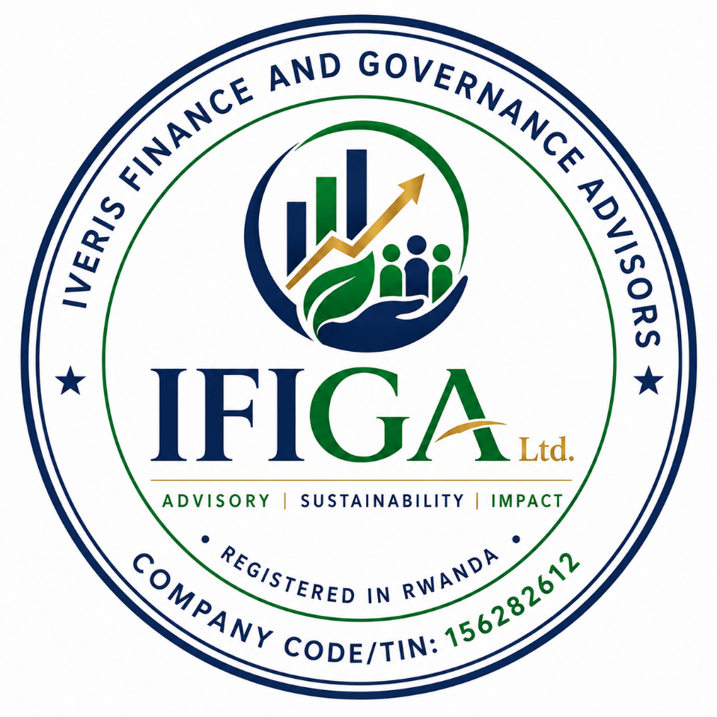

Header and footer (Letter): Draft1
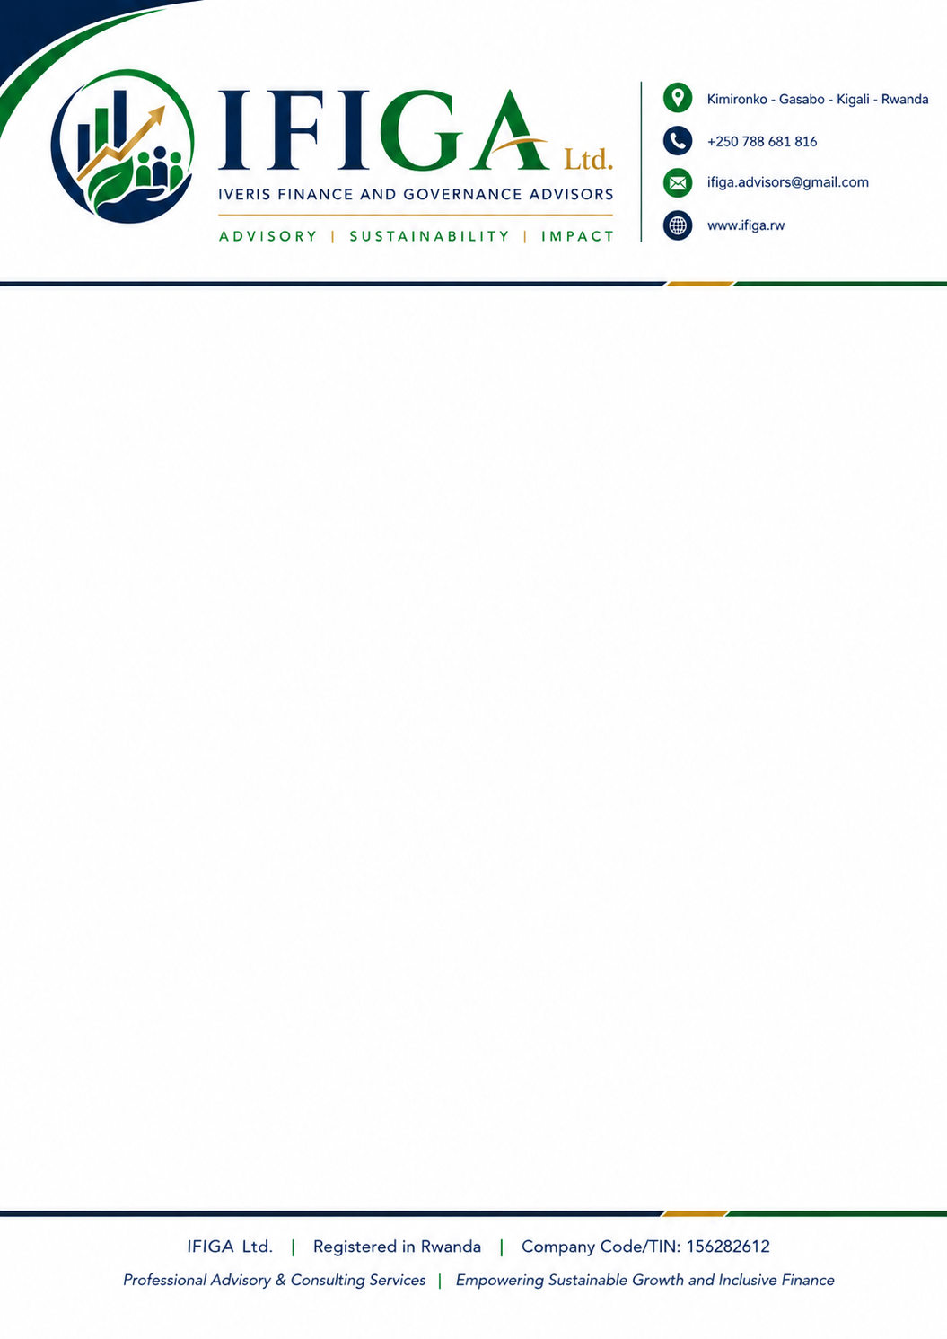
Header and footer (Letter): Draft2
